15. Implementing concurrency control mechanisms to handle multiple simultaneous transactions.

use school;
CREATE TABLE accounts5 (
id INT PRIMARY KEY,
balance DECIMAL(10,2)
);
INSERT INTO accounts5 VALUES (1, 1000.00), (2, 2000.00);
select * from accounts5;

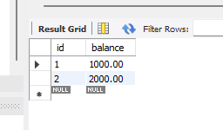

DELIMITER $$
CREATE PROCEDURE transfer_fund6(
IN from_account INT,
IN to_account INT,
IN amount DECIMAL(10,2)
)
BEGIN
DECLARE current_balanceDECIMAL(10,2);
START TRANSACTION;

--Lock the row for update to prevent race condition
SELECT balance INTO current_balance FROM accounts5 WHERE id=from_account FOR UPDATE;
IF current_balance<amount THEN
SIGNAL SQLSTATE '45000' SET MESSAGE_TEXT='Insufficient funds';
ELSE
UPDATE accounts5 SET balance =balance-amount WHERE id=from_account;
UPDATE accounts5 SET balance=balance+amount WHERE id=to_account;
END IF;
COMMIT;
END$$
DELIMITER ;
CALL transfer_fund6(1,2,500);
select * from accounts5;

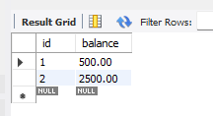
SHOW VARIABLES LIKE 'transaction_isolation';

